11.76: (a) Writing an equation for the torque on the right-hand beam, using the hinge as an axis and taking counterclockwise rotation as positive:
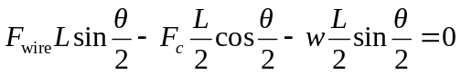
where is the angle between the beams, 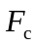 is the force exerted by the cross bar, and is the weight of one beam. The length drops out, and all other quantities except are known, so

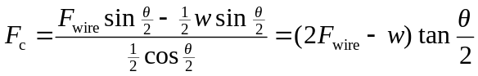

Therefore
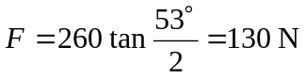
b) The cross bar is under compression, as can be seen by imagining the behavior of the two beams if the cross bar were removed. It is the cross bar that holds them apart.

c) The upward pull of the wire on each beam is balanced by the downward pull of gravity, due to the symmentry of the arrangement. The hinge therefore exerts no vertical force. It must, however, balance the outward push of the cross bar: 130 N horizontally to the left for the right-hand beam and 130 N to the right for the left-hand beam. Again, it’s instructive to visualize what the beams would do if the hinge were removed.

